

The Wildcat Zone

Woodland Park Magnet School February 2022

Be Respectful, Be Compassionate, Be Great

Mardi Gras

Mardi Gras is known as Fat Tuesday. It is always on a Tuesday. The colors of Mardi Gras are green, gold, and purple. People like to wear mask, go to parades and catch throws during Mardi Gras. Throws may consist of beads, hats, hula-hoops, candy and cups. I like to attend Mardi Gras in New Orleans with my daddy. My family always have a great time.

Author: Diamond Andrews, 3rd Grade



Meet Our Wildcat

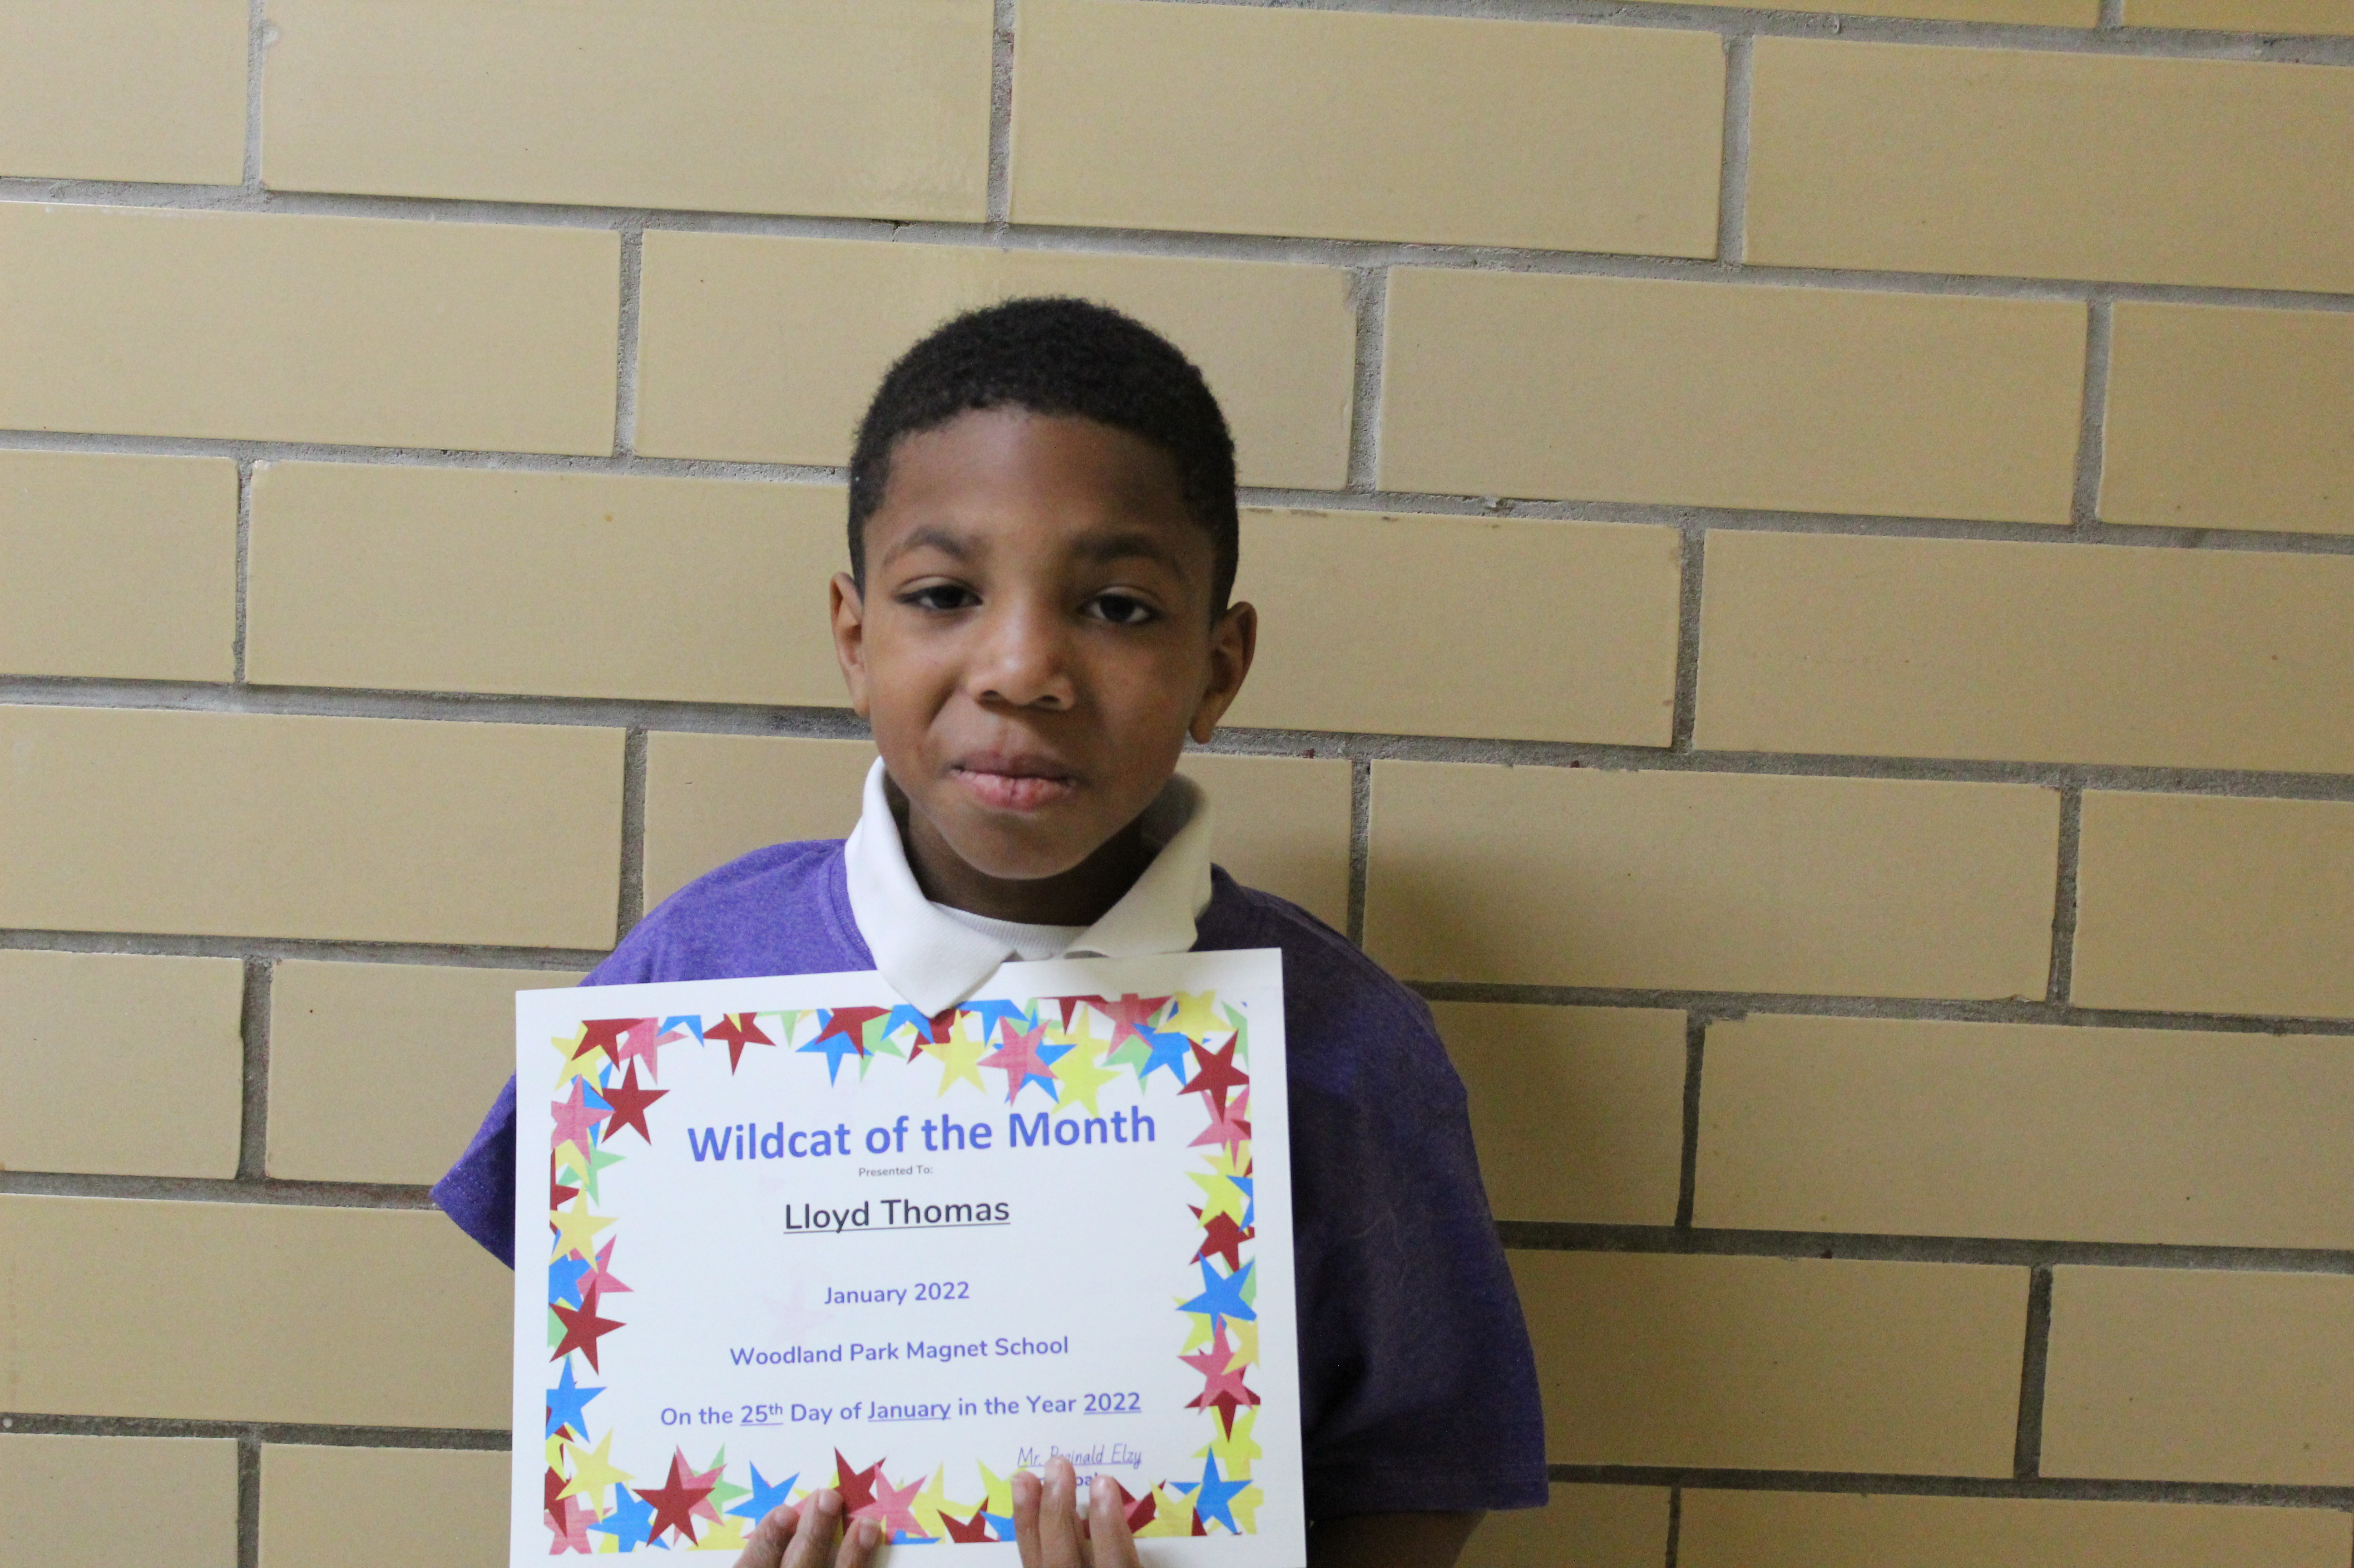

Lloyd Thomas is a second grader in Ms. Tantillo’s class. His favorite color is blue and loves pizza. He enjoys going outside and playing with his friends. He wants to be a tree climber when he grows up.

Author: Zaiden Louis, 2nd Grade

Meet Our Teacher



Ms. Tamika Smith is a first grade para professional. She loves to listen to music and shop. Her favorite snacks are sour cream chips and Hershey chocolate bar. She has one child and her favorite color is coral.

Author: Brigitte Chimilio Oreallana,   
2nd Grade



Black History

Every February, the U.S. honors the contributions and sacrifices of African Americans who have helped shape the nation. Kobe Bryant is one of those African Americans. He was famous for being one of the best basketball players in the history of the NBA. He played guard for the Los Angeles Lakers for 20 years. He was known for his tough defense, vertical leaps, and his ability to score winning baskets at the end of the game. He is widely considered the best basketball prayer of the 2000s and perhaps one of the best of all time.

Author: Kendrick Mosley, 3rd Grade



What It Means To Me?

While learning about Black History this month, we were asked to reflect on what some quotes mean to us. Martin Luther King, Jr. wrote one of the quotes. The quote I picked is “Darkness cannot drive out darkness only light can do that. Hate cannot drive out hate only love can do that.” I think is means you should step out of the shadows and step into the light. You should not hate… you should love.

Author: King Poindexter, 3rd Grade



Joke

What did one piece of toast say to the other?

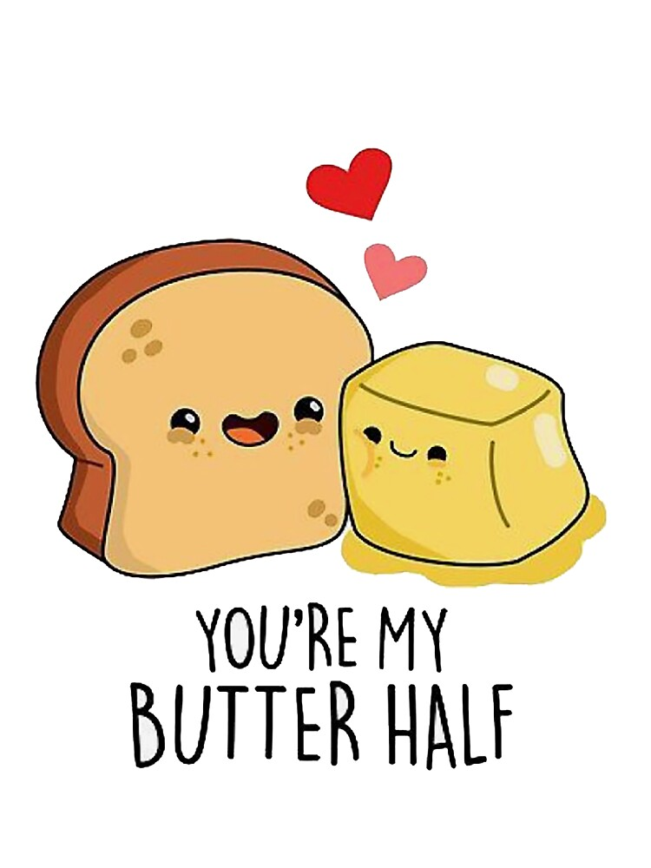

“You’re my **butter** half!”

Author: Jamarrian Hart,   
2nd Grade

Valentine’s Day



February 14th was Valentine’s Day. This is a time when people come together to show love. I made my mom a card to show how much I love her.

Author: A’zyrie Schaffer, 3rd Grade

Important Upcoming Dates:

* Feb. 25: PBIS Mardi Gras Event
* Feb. 28 – March 2: Mardi Gras Holiday
* March 7: PAWS Meeting at 9:00
* March 7 – March 11: Read Across America Spirit Week
* March 11: End of the third 9-weeks
* March 15: Pre-K/K Field Trip
* March 16: Ms. Foster/Ms. Foy/1st/2nd Grade Field Trip
* March 17: 3rd Grade Field Trip
* March 18: PBIS Event
* March 22: Spring Pictures

